Whitney Woelmer, Master’s Prospectus Outline

**Overall Introduction**

Freshwater ecosystems have been intricately interwoven with society since the dawn of humanity. Whether it be natural lakes and streams or impoundments created by humans for human purposes, freshwater ecosystems provide crucial services to society. These ecosystem services range from providing important cultural connections, serving as sources of recreation and tourism to providing major sources of food production, and importantly, drinking water. But as human populations have grown and our need for freshwaters has increased, these resources have been degraded.

Climate change and human population growth are two factors that have put the health of freshwater ecosystems in jeopardy (some refs). Eutrophication, excessive nutrient enrichment of a freshwater ecosystem, is increasing in both severity and occurrence (REFS), just one water quality impairment as a result of global change. The economic impact of harmful algal blooms (HABs), a result of eutrophication, range from decreased tourism to public health to mitigation for water treatment plants, was over $400 million in the United States in the year 2000 alone (ref in VWRRC app).

The influence of human activity can quickly cascade across landscapes through the transport of water through and among stream networks downstream to lakes and reservoirs. Changes in land use from forested to agricultural, for example, can both increase the magnitude of nutrient availability through the application of fertilizer of fields, and can also increase the transport of these nutrients to freshwater bodies, which can result in rapid changes in nutrients concentrations and resulting biological activity in both lotic and lentic waterbodies. ANOTHER SENTENCE ABOUT CASCADING CLIMATE EFFECTS.

Consequently, we need to better understand these rapid temporal and spatial changes in nutrient and biological communities as a result of changing climate and land use. By studying nutrient and phytoplankton dynamics at a high-resolution spatial scale, we can gain an understanding of chemical and biological hotspots of activity and further identify areas of greater risk of eutrophication under a changing climate.

Research to understand how systems are currently changing and developing efforts to anticipate their future response is more important than ever. to allow society to coexist with changing ecosystems, for managers to preemptively manage/anticipate impending poor water quality events. AN EXAMPLE OF WHERE A FORECAST WOULDVE BEEN REALLY HELPFUL: Lake Erie 2014 example, major social and economic loss.

Together, my two chapters will better inform the scientific community on where water quality is most impaired within small, eutrophic drinking water reservoirs and produce forecasts of how this water quality will change in response changing conditions in the future.

**Proposed Research**

*Chapter 1: Developing near-term forecasts of phytoplankton in a drinking water reservoir***Introduction**

As our world continues through an era of global climate change and human populations continue to grow (REFS), understanding not only the current state of our freshwater ecosystems, but predicting how they will respond tomorrow, next week, and next year is of utmost importance. In particular, knowing future water quality in advance would provide a substantial benefit to managers and freshwater ecologists by allowing them to make preventative measures when a poor water quality event is predicted rather than managing an ecosystem after poor water quality has already occurred. Being able to anticipate an impairment in water quality could help save millions of dollars in water treatment costs, as well as protecting the trust required between a community and their water utility by avoiding a shutdown of water resources. Therefore, the ability to forecast the future state of our drinking water sources is of utmost importance to society and freshwater ecology as a discipline.

Forecasting as a technique outside of ecology has been developing for decades in many disciplines and has substantial breadth. Uses of forecasting can be found in many fields and applications, ranging from the well-known and widely-used weather forecasts to epidemiological forecasts of population mortality (Lee and Carter, 1992) and global Alzheimer’s trends (Brookmyer et al. 2007) to forecasts of bankruptcy declaration in the United States (Shumway et al. 2001). Many of these fields have been priming their forecasting abilities for decades (Shumway et al. 2001). For example, the field of weather forecasting has increased accuracy ratings from ~25% when the field began to develop in the 1950’s to ~80% accuracy in the early 2000’s with 36-hour forecasts (Dietze, 2017). This slow yet substantial increase in forecast accuracy over the past 50 years shows that progress cannot be expected to be immediate, and that there is merit in developing forecasts even when they have low accuracy.

Still, the development of forecasts specific to ecological systems and ecosystem services is still in its relative infancy (Dietze, 2017). The current shift in the scientific community towards publishing data in publicly accessible venues (cite FAIR here), as well as the development of high-frequency sensors which result in massive amounts of data (Hampton refs) have both enabled the field of ecological forecasting to recently expand. However, as the development of ecological forecasting is still in very early stages, there is not yet a consensus as to the best approach for making ecological forecasts. To better understand the current state of studies using ecological forecasting and their approaches, I conducted a high-level literature review. Studies were found using the Google Scholar database and the search terms ‘ecological forecasting’ and ‘forecasts.’ Studies which met the following requirements were selected as using ecological forecasting methods: they must 1) use models, 2) quantify uncertainty to make a probabilistic forecast or forecasts, and 3) run the model outside a specified training period (Table 1).

Empirical methods were favored a majority of times (65%, n= 17, Table 1) in current forecasting studies selected in the literature review. Empirical time series approaches were likely popular because of their data-driven nature; they are inherently developed for a single particular ecosystem because they are based on past trends within that ecosystem. Input time series data for empirical models are commonly available through routine monitoring of a system and empirical models are generally simple and quick to develop and implement (REF). However, because empirical models are built on the historical conditions of a system, if future conditions are outside the realm of past conditions, models might no longer be able to capture the mechanism responsible for changes (Dietze 2017). In contrast to empirical time series models, process-based models were favored in just over a third of the studies examined (35%, n=17, Table 1). It is not surprising that process-based models are currently less frequently used in the ecological forecasting literature given that they often require more input data, as well as more time and expertise to properly calibrate the multitude of parameters in order to more accurately represent a specific waterbody. However, these models may be especially useful in the current era of global change given their ability to explain underlying mechanisms which cause a given response, and are likely more generalizable to other systems because they are based on a set of fundamental equations rather than the historical pattern of a single system.

The studies examined in the literature review spanned the realm of basic and applied research, showing multiple motivations to understand the current state of science and inform management/decision-making. While a majority of the studies in our literature review were conducted to inform the field of basic freshwater science and forecasting (73%, n = 15), all of the studies whose forecasting products were directly tied to a management tool or product were focused on forecasting various aspects of aquatic ecosystems, including water quality variables as well as species distributions in marine environments and habitat quality. This illustrates not only the interest in the scientific community to understand changing freshwater systems, but the need by managers and stakeholders for probabilistic forecasts in order to cope with and adapt to changing conditions in freshwater ecosystems.

|  |  |  |  |  |
| --- | --- | --- | --- | --- |
| Table 1. Summary of literature review targeting studies using ecological forecasting methods. | | | | |
| Authors & Year | Best Model | Forecast Product | Use of forecast product in decision making (Y/N) | Notes |
| Araujo et al. 2005 | Empirical | Bird species ranges | N |  |
| Araujo et al. 2006 | Empirical | Amphibian and reptile species distributions | N |  |
| Brown et al. 2013 | Process-based and empirical | Chesapeake Bay water quality | Y |  |
| Dean et al. 2004 | Process-based | Carbon sequestration in forests | N |  |
| Estes et al. 2013 | Empirical | Productivity and suitability of crops in South Africa | N |  |
| Fenocci et al. 2019 | Process-based | Phytoplankton dynamics | N |  |
| Hazen et al. 2017 | Empirical | Blue whale density | Y |  |
| Lindegren et al. 2013 | Process-based | Baltic cod dynamics | N |  |
| Liu et al. 2006 | Empirical | Coral Reef Bleaching | Y |  |
| Martinez-Meyer et al. 2004 | Empirical | Ecological niches of mammal species | N |  |
| Perretti et al. 2013 | Empirical | Species abundance | N |  |
| Stow et al. 2003 | Process-based and empirical | Estuarine water quality | Y |  |
| Thomas et al. 2018 | Empirical | Phytoplankton dynamics | N |  |
| Thuiller et al. 2004 | Empirical | Tree species distributions | N |  |
| White and Nemani 2004 | Process-based | Soil water | N |  |

My first chapter will focus on addressing the knowledge gap in ecological forecasting regarding how best to forecast water quality. We will focus on the dynamics of HABs (harmful algal blooms) as one metric of water quality in our system, which will be measured by changes in phytoplankton abundance. I will produce hindcasts and near-term iterative forecasts of phytoplankton in a drinking water reservoir using both an empirical and a process-based approach. Model performance will be assessed by a suite of metrics addressing both the ability of the model to capture overall phytoplankton dynamics, as well as extreme events (blooms). My work will specifically address the following questions:

* + Question 1: How well can an empirical model vs. a process-based model hindcast observed phytoplankton dynamics?
  + Question 2: How well can an empirical model and a process-based model forecast near-term phytoplankton dynamics over a 16-day period (assessed by comparing quantified uncertainties of a probabilistic forecast with observed dynamics)?
  + Question 3: How does an ensemble model approach improve 16-day forecasts of phytoplankton over a single model approach?

Chapter 1 will thus span the field of applied and basic forecasting science by**: 1) informing managers and decision-makers about which variables are most important for routine monitoring and management of water quality in the face of land use and climate change through the selection of variables within the empirical model, 2) providing essential information to the freshwater research community regarding modeling approaches to forecasting water quality.**

**Methods**

*Study Site*

Falling Creek Reservoir (FCR) is a small (~12 ha), shallow (maximum depth = ~9.3 m) dimictic drinking water reservoir located in southwestern Virginia. FCR is owned and operated by the Western Virginia Water Authority (WVWA). The watershed of FCR is almost entirely forested, although the reservoir continues to exhibit incidences of poor water quality as a result of historical eutrophication (Gerling et al.2016). The major water source to FCR comes from a single tributary which flows from Beaverdam Reservoir (BVR; Figure 1).

Figure 1. Map of Falling Creek Reservoir and Beaverdam Reservoir and their watersheds.

*Historical and sensor dataset*

An extensive, routine monitoring dataset of water quality in FCR has been collected since 2013 in collaboration with the WVWA and Virginia Tech. This dataset includes meteorological, physical, chemical, and biological data collected both at the deep hole of the reservoir and at the major inflow to FCR (add lots of lab citations here). The inflow dataset also includes discharge to the reservoir measured every 15 minutes at a weir installed at the stream site. More recently, as part of the Smart and Connected Communities (SCC) project, FCR has been outfitted with numerous high-frequency sensors to capture real-time changes in water quality. These data are streamed wirelessly to a staging server and pushed to Github multiple times per day. Sensor data include multiple meteorological, physical, chemical, and biological variables.

*Model Development (Question 1)*

We will develop both an empirical and a process-based model to forecast chlorophyll-a in the surface water (1.0 m) at FCR during the summer stratified period (May-October), when phytoplankton populations are at their highest. The training period for both models will be 2013-2016 during which we have regularly, weekly coverage of both response and driver data. Both models will be validated using data from 2018.

Empirical: ARIMA

We chose an autoregressive integrated moving average (ARIMA) generalized linear model for our empirical approach to forecast chlorophyll-a in FCR. The autoregressive term in ARIMA was determined by selecting the previous timestep of chlorophyll-a with the highest Pearson’s r correlation coefficient with the current measurement of chlorophyll-a. From a pool of 53 potential meteorological, physical, chemical, and biological driver variables, we first focused on driver variables that have biological significance for phytoplankton growth and which are also predictable in nature (e.g., temperature, discharge). We excluded variables that were correlated with each other through the use of a Pearson’s correlation analysis (r > 0.5 & r < -0.5). Using these variables, we developed all possible ARIMA combinations with the selected driver variables, and the best model was determined by AICc (corrected Akaike’s Information Criterion).

Process-based: GLM

We used the General Lake Model, Aquatic Ecodynamics (GLM-AED) as our process-based model. GLM-AED is a one-dimensional hydrodynamic model, etc.

Model Assessment

Model performance will be assessed using a number of metrics currently being used in the ecological forecasting field. As one metric alone cannot determine if a model performs better than another, a holistic approach examining several model performance metrics will be used.

Comparisons of observed and model descriptors will include the mean, standard deviation, quantiles (Dietze 2017), and kurtosis (Bennett et al. 2013). Forecasts are said to be in consensus if they are insignificantly different from the sample mean (Gregory et al. 2001)

Model outputs will also be compared with each other using the following performance metrics:

* RMSE
* R2 (variation from the 1:1 line)
* Bias
  + SD(model)/SD(data)
  + Base R bias calc mean(observed – model)
* Slope of the regression btw model and OBS
* Pearson’s correlation between the model and OBS
* Area under the curve (Araujo, Thuiller, and Pearson 2006)

Lastly, model performance will be examined through visual assessment of the following diagnostic figures (Dietze 2017):

* Observed and model predictions over time
* Predicted vs. observed + 95% confidence interval

*Forecasting Framework: FLARE (Question 2)*

After addressing Question 1, both models will be integrated into an existing forecasting framework, Forecasting Lake and Reservoir Ecosystems (FLARE), to produce iterative near-term 16-day forecasts of chlorophyll-a (Thomas et al, in prep). FLARE is designed to pull 2-week weather predictions from the National Oceanic and Atmospheric Administration (NOAA) GEFS server to force both ARIMA and GLM-AED on a daily time step. Additionally, ARIMA’s autoregressive term will be forced using our established sensor-cloud network to provide yesterday’s chlorophyll-a concentration as well as for comparison with the previous days’ forecasts. Lastly, inflow discharge data for both models will be estimated using an autoregressive linear model of discharge based on the previous day’s mean discharge at the major inflow to the reservoir. Driver uncertainty will be calculated for both ARIMA and GLM-AED forecasts by propagating the uncertainty associated with the NOAA weather forecasts. Parameter uncertainties for both ARIMA and GLM-AED will be calculated by sampling from a distribution of key parameters within each model. Forecast effectiveness will be assessed using a suite of performance metrics calculated by comparing the forecast model outputs to the observed high-frequency chlorophyll-a sensor in FCR. Assessment metrics will be calculated for various conditions (summer stratified period, fall mixed period, winter ice period, and following storm events) to determine which approach is most robust under different reservoir and meteorological conditions.

*Integrated Model Averaging (Question 3)*

In order to develop the most informative forecast of chlorophyll-a, we will develop a weighted model including both empirical and process-based model outputs averaged to incorporate the strengths of multiple models and compare it with a single model approach. This will allow the ensemble forecast to capture as much variability as possible in chlorophyll-a and the different strengths of the two models**. If, for example, one model does a better job predicting chlorophyll-a at lower concentrations, while another model is more effective at capturing large bloom events, the goal is using the relative strengths of both models to improve overall chlorophyll prediction (or something like that!).** I anticipate that for low probability yet high impact events such as phytoplankton blooms, an ensemble approach may be necessary to capture these peaks in phytoplankton concentration that may operate under different mechanisms. Incorporating multiple models will enable us to develop an early-warning system which will alert users when conditions that indicate a peak in phytoplankton is likely to occur.

**Preliminary Results**

Question 1: Hindcasts of chlorophyll-a

Using the summer period of 2013-2017 as our training period, we developed and calibrated both an empirical model (ARIMA) and process-based model (GLM-AED). Our best-fitting ARIMA model over 2013-2016 included discharge to the reservoir and shortwave radiation. ARIMA hindcasted chlorophyll-a over 2013-2016 with an R2 = 0.44 and RMSE = 1.71 ug/L. The ARIMA model was able to successfully capture fluctuations at lower chlorophyll-a concentrations (<10 ug/L) (Figure 2). However, when chlorophyll-a reached values above ~10 ug/L, the model the model was unable to recreate these observed dynamics. GLM-AED was calibrated over 2013-2016 and hindcasted chlorophyll-a with R2 = XXX and RMSE = YYYY. While GLM-AED does not capture the same fluctuations in chlorophyll-a dynamics as the empirical model, it does capture some large peaks in chlorophyll-a that the ARIMA does not. 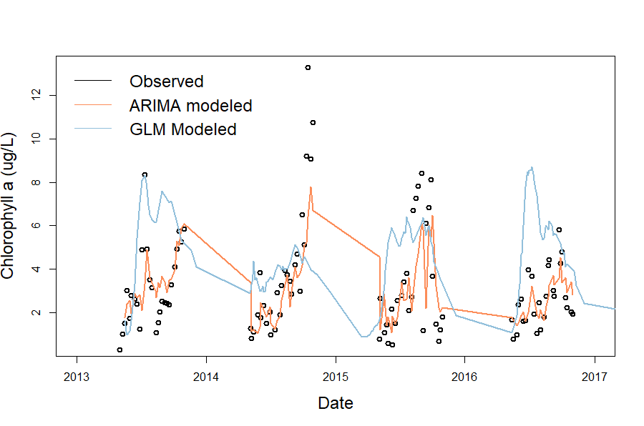

Figure 2. Observed and modeled chlorophyll-a data over 2013-2016.

Table 2 shows the proposed timeline of remaining steps to finish work required for Chapter 1 and to address the steps needed to address Questions 2 and 3.

|  |  |  |  |  |  |
| --- | --- | --- | --- | --- | --- |
| **Table 2. Proposed timeline for Chapter 1** *Black boxes indicate completed tasks, gray boxes indicate proposed completion* | | | | | |
|  | Fall 2018 | Spring 2019 | Summer 2019 | Fall 2019 | Spring 2020 |
| Develop ARIMA GLM-AED |  |  |  |  |  |
| Calibrate GLM-AED |  |  |  |  |  |
| Produce hindcasts |  |  |  |  |  |
| Validate model (Q1) |  |  |  |  |  |
| Adapt FLARE code for ARIMA (Q2) |  |  |  |  |  |
| Create integrated model average (Q3) |  |  |  |  |  |
| Run forecasts in FLARE |  |  |  |  |  |
| Submit manuscript, *target journal: Ecological Applications* |  |  |  |  |  |

**Chapter 2. Spatial heterogeneity of nutrients and phytoplankton along a double reservoir continuum**

Reservoirs are ecosystems marked by physical heterogeneity and are classically defined as having a gradient of riverine, transitional, and lacustrine zones (Thornton et al. 1990). The nutrient chemistry and biological communities change substantially as they travel along this gradient, as demonstrated by the large change in nutrient concentrations that generally occurs between the inflow and outflow of reservoirs (Harrison et al. 2009, Kling et al. 2000, Powers et al. 2015). However, studies examining how concentrations of nitrogen, phosphorus, and chlorophyll-a within reservoirs change along the reservoir gradient are rare, and those that do measure nutrients and biology along the reservoir gradient report inconsistent patterns. Further, because managers generally extract water from reservoirs for drinking from the deep hole only, and most reservoir studies only focus on the lacustrine zone (cite lots of studies here) there is a critical lack in the understanding of how these water quality variables changes along a reservoir gradient. Because there is a lack of research conducted along the reservoir gradient, we lack understanding of how sites along a reservoir gradient disproportionally affect nutrient concentrations and chlorophyll-a which are measured at the deepest site of the reservoir. Many important biogeochemical processes occur along this gradient that need to be considered in order to understand these inconsistencies. For example, some of the inconsistencies could be due to the location of sampling site in relation to reservoir “hot spots” of nutrient processing (McClain et al. 2003) that may occur at the intersection between the zones.

Studies looking at heterogeneity of nitrogen along a reservoir gradient report a number of trends. Some have found that nitrogen is highest in the riverine zone due to high nutrient inputs from the watershed (Soares et al. 2012), while others have found that the transitional zone, where turbulence is decreased yet nutrients are still abundant, is a hotspot for nitrogen fixation across reservoirs of varying trophic status, effectively increasing the concentration of NH4 (Scott et al. 2009). Additionally, when the hypolimnion of a reservoir becomes anoxic, it can lead to disproportionately high levels of NH4 being released from the sediment while nitrate (NO3) is concurrently reduced and effectively decreased in concentration, especially within the lacustrine zone (Gerling et al. 2006), which can easily be brought to the surface by a mixing event.

Similar to nitrogen, patterns in chlorophyll-a heterogeneity are inconsistent between studies. There is some support to show that chlorophyll-a is highest in the riverine zone, decreasing along the downstream gradient (Scott et al. 2009). In contrast, others report the transitional zone as being an especially active zone for phytoplankton activity (Rychtecky & Znachor, 2011; Thornton 1990), and others still have found the lacustrine zone to have the highest chlorophyll-a when nutrients are not limiting ecosystems that are not limited by nutrient availability (Soares et al. 2012). Further, Borges et al. (2008) found that the longitudinal pattern of heterogeneity of chlorophyll-a was variable among seasons in two tropical reservoirs in Brazil.

Trends in reservoir phosphorus concentrations are less often reported than nitrogen or chlorophyll. One study of a large, deep reservoir in the Czech Republic showed that both soluble and total phosphorus decreased along the reservoir gradient (Rychtecky & Znachor, 2011). Borges et al. (2008) found contrasting patterns in two reservoirs in Brazil, one showing a decrease in phosphorus along the reservoir gradient, while another showed no clear longitudinal pattern. Sedimentation processes also influence longitudinal distributions of phosphorus, with classical reservoir theory positing that sedimentation should be highest in the transitional zone, which should lead to an overall decrease of nutrients along the reservoir gradient (Thornton 1990). However, internal loading of soluble phosphorus can play a substantial role in phosphorus concentrations during anoxic conditions in the hypolimnion, which may lead to increases in phosphorus in the lacustrine zone (Thornton 1990). While all of these studies agree that spatial heterogeneity of nutrients and phytoplankton exists along a reservoir gradient, the lack of consistency among studies necessitates additional research, especially in smaller reservoirs, which overall remain understudied relative to larger reservoirs. In smaller reservoirs, the transitions among zones may happen more rapidly, which could result in greater variability in nitrogen, phosphorus, and chlorophyll along the downstream gradient.

An important factor that can affect the heterogeneity of chemical and biological variables along reservoir gradients is hydrologic flow. Under low flow conditions, residence times of reservoirs and streams are increased, resulting in slower export of nutrients and more time for biotic processing (Saunders and Kalff, 2001). This can lead to an increase in chlorophyll concentrations while nutrient conditions remain high, but external loading of nutrients is low under this scenario and nutrients can become quickly depleted. In comparison, high flow conditions may result in less biotic uptake of nutrients by phytoplankton as water is flushed out more rapidly, but high flow also brings in high levels of external nutrients which are often limiting to phytoplankton. This can result in high nitrogen and phosphorus, but low chlorophyll concentrations. These concentrations are typical of the deep hole of a reservoir, which often the only study site in reservoir experiments, and there is less known about how these varying hydrologic regimes effect nutrient and chlorophyll concentrations along the entire reservoir gradient. However, one study measured a direct decrease in spatial heterogeneity of phytoplankton with increases in residence time (Soares et al. 2012), illustrating the need to better understand how nutrient and chlorophyll vary not just at the lacustrine site but along the entire reservoir gradient. Further support for the importance of hydrologic flow in driving phytoplankton at the lacustrine site comes from preliminary results of Chapter 1. The empirical model from my forecasting chapter revealed the importance of upstream stream discharge, or changes in hydrologic flow, to phytoplankton dynamics at the deepest site of a reservoir. This finding highlights the importance of gaining a better understanding of how upstream discharge can influence nutrient dynamics along the reservoir continuum before reaching the lacustrine zone.

In the face of global change, understanding how and why freshwater systems vary is more important than ever. As storms are projected to increase in frequency and severity with global climate change (REF), we are likely to see increases in both hydrologic flow and mixing regimes within reservoirs, both of which will impact the heterogeneity of nutrients and chlorophyll along a reservoir continuum. Identifying areas within a reservoir where chemical or biological concentrations are disproportionately high can help prioritize management efforts to areas within freshwater systems that are more vulnerable to eutrophication or changes in trophic status.

Finally, a major driver of differences in chemical and biological composition of a waterbody is the presence of upstream waterbodies. Studies looking at the effect of watershed connectivity and lake chain show that downstream nutrients are significantly reduced by the presence of impoundments upstream (Bosch et al. 2009, Powers et al. 2015, Stachelek & Soranno 2019). In contrast, Brown et al. (2008) found that increases in upstream lake area was significantly correlated to increases in total nitrogen of small mountain lakes..

**Proposed Work**

My second chapter will focus on the longitudinal spatial heterogeneity of nitrogen, phosphorus, and chlorophyll-a in Beaverdam Reservoir (BVR) and Falling Creek Reservoir (FCR) and the influence of hydrologic flow on this heterogeneity. This research will inform our understanding of how reservoirs will respond to global climate change, which is expected to include more variability in hydrologic flow and resultant residence times as a result of changing precipitation patterns.

***Question 1****: What is the longitudinal heterogeneity of nitrogen, phosphorus, and chlorophyll-a along a double reservoir continuum?*

**Hypothesis 1**: I hypothesize that there will be spatial heterogeneity in nitrogen, phosphorus, and chlorophyll-a within both BVR and FCR along a reservoir gradient of riverine to transitional to lacustrine (Figure 3). I expect nitrate (NO3) to follow the traditional view of nutrient decrease along the reservoir gradient due to both sedimentation and biotic uptake (Thornton 1990). In contrast, I expect to find a different pattern with soluble reactive phosphorus (SRP) and ammonium (NH4), due to the importance of internal loading in our shallow, eutrophic reservoirs which experience substantial anoxia during the summer stratified period (Gerling et al. 2016). I expect that both SRP and NH4 will enter the riverine zone at relatively high concentrations from stream inputs, decrease within the transitional zone due to sedimentation, and increase in the lacustrine zone as a result of internal loading under anoxic conditions. Lastly, I expect to find low chlorophyll concentrations in the riverine zone due to high flow and low nutrient conditions from stream inputs and increases in the transitional zone in response to increased nitrate, followed by a further increase in the lacustrine zone as internal phosphorus becomes abundant.

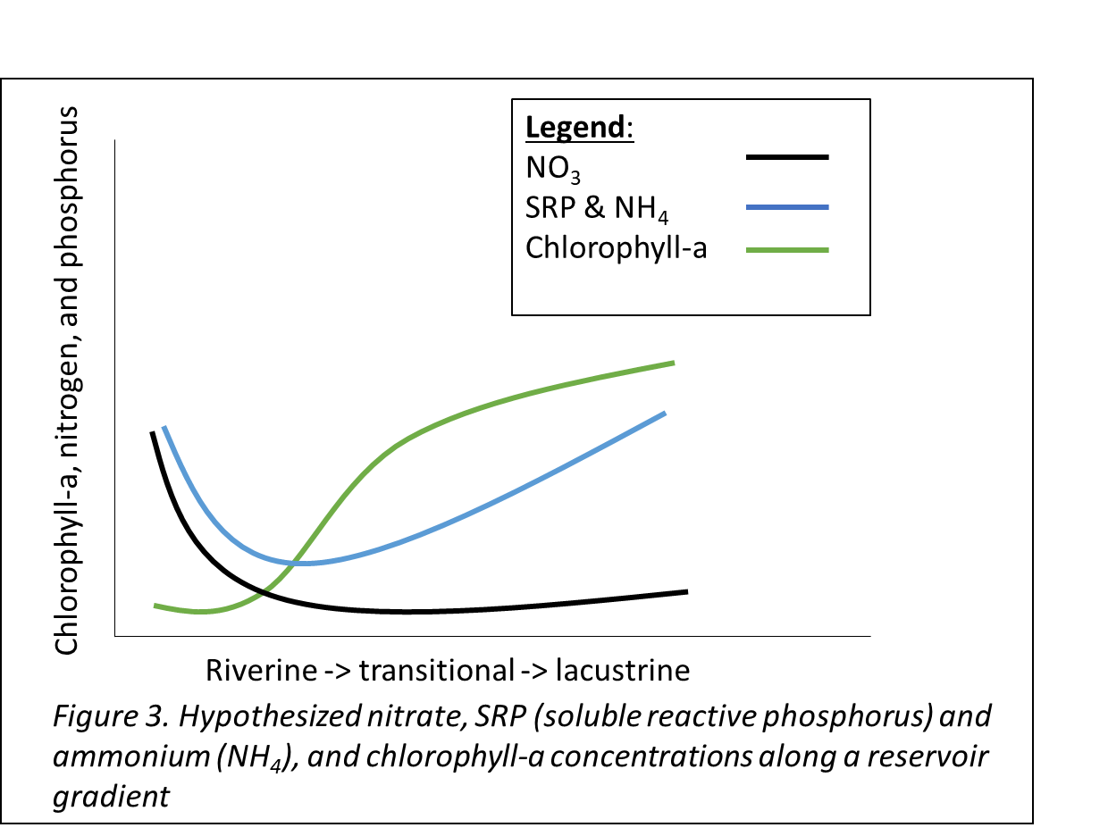

***Question 2****: How does a gradient of hydrologic flow conditions influence longitudinal heterogeneity?*

**Hypothesis 2:** I hypothesize that increases in flow will increase spatial heterogeneity in both reservoirs (Figure 4). Spatial heterogeneity will be calculated as the coefficient of variation between sites within a reservoir. Do I expect reservoir chain number to have an effect on heterogeneity?

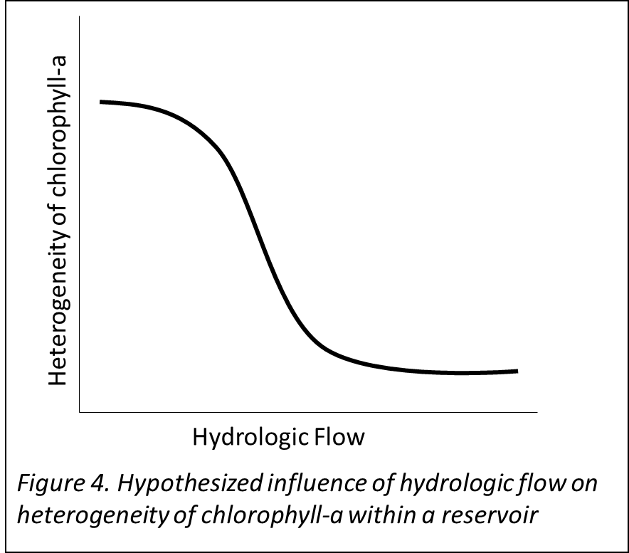

***Question 3****: Does the presence of an upstream reservoir influence the relative concentration of phytoplankton in a downstream reservoir?*

**Hypothesis 3**: I hypothesize that the relative concentration of nitrogen will increase with reservoir chain number, and the relative concentrations of phosphorus and chlorophyll-a will decrease with reservoir chain number (Figure 5).

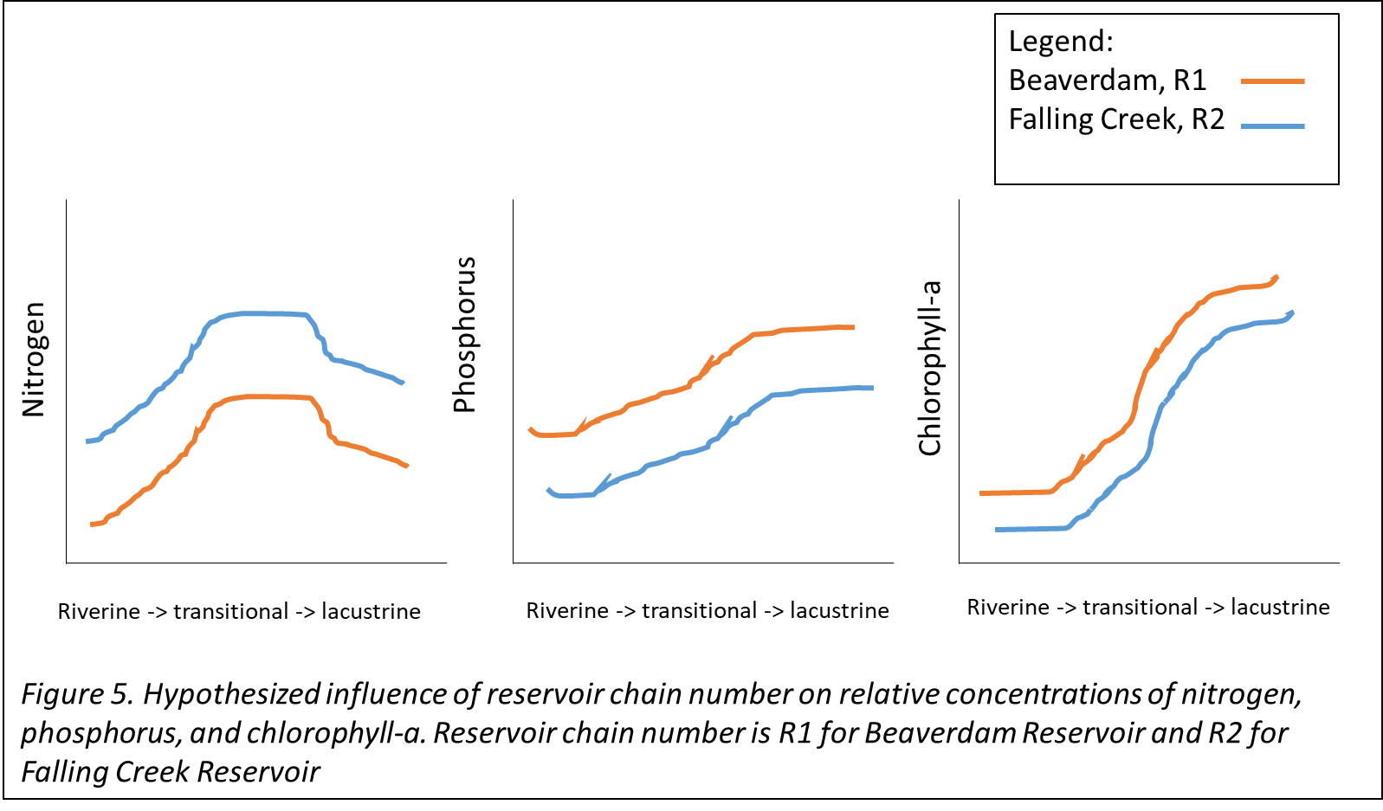

**Methods**

*Study site*

Beaverdam Reservoir (BVR) is a small (39 ha), shallow (maximum depth < 13 m), dimictic reservoir owned and operated by the Western Virginia Water Authority (WVWA) and located in Vinton, VA. BVR has multiple inflow streams, but we have selected the major inflow in the western and the eastern arms for this study (Figure 1, above). BVR has an outflow pipe that flows to Falling Creek Reservoir (FCR), a smaller (), shallower (), dimictic reservoir, also owned and operated by WVWA.

*Proposed Field sampling, summer 2019*

We intend to sample the reservoir continuum once per month from May to September to capture a gradient in seasonal conditions. Additionally, we will add adaptive sampling events to capture a gradient of hydrologic flow conditions (n = ~8).

* Sites
  + The major stream inflow to the western and eastern arms of BVR (n = 2)
  + 4 sites within BVR to capture a gradient of riverine, transitional, and lacustrine conditions, as well as the outflow pipe to FCR
  + 4 sites along BVR-FCR inflow stream
  + 5 sites within FCR to capture a gradient of riverine, transitional, and lacustrine conditions
  + FCR outflow
* Data collection
  + Nutrient chemistry (total and soluble nitrogen & phosphorus)
  + Discharge at stream sites (using a flowmeter)
  + Physical characteristics from YSI (dissolved oxygen, conductivity, temperature)
  + Chlorophyll-a
* Sampling frequency

*Data analysis*

* + Coefficient of variation to determine heterogeneity of sites within BVR and FCR
  + Generalized linear models to analyze drivers of nutrient and phytoplankton dynamics along a stream-reservoir gradient
    - Physical, chemical, and meteorological variables

CITATIONS (Incomplete)

Thornton, K. W., B. L. Kimmel & F. E. Payne (eds), 1990. Reservoir limnology: ecological perspectives. Wiley, New York.